

**Epoka University**

**Faculty of Engineering and Architecture**

**Department of Computer Engineering**

**CEN302 – Software Engineering**

**HMS Requirements Specification**

**March 29, 2025**

**Prepared by:**

**Alban Plakalliu**

**Erlis Ciko**

**Gleris Xhoxha**

**Klei Qorri**

**Deni Mekollari**

**Erblin Boletini**

***Received by: Msc. Shkumbin Fida, Msc. Edlira Cani***

Table of Contents

**1.** **Executive Summary** 4

**1.1** **Project Overview** 4

**2.** **Product/Service Description** 5

**2.1 Product Context** 5

**2.2 User Characteristics** 5

**2.1** **Assumptions** 6

**2.2** **Constraints** 6

**2.3** **Dependencies** 7

**3.** **Requirements** 8

**3.1** **Functional Requirements** 8

**3.2 Non-Functional Requirements** 10

**3.2.1 Product Requirements** 10

**3.2.2 Organizational Requirements** 12

**3.2.3 External Requirements** 14

**3.3 Domain Requirements** 15

**4 Software Design/Diagrams** 15

**4.1 Requirement Analysis** 15

**4.1.1 User Scenarios** 15

**4.1.2 User Cases** 19

# **Executive Summary**

## **Project Overview**

The Hospital Management System (HMS) aims to streamline administrative and medical operations within a medical facility. The system will facilitate patient record management, appointment scheduling, and secure communication between medical professionals and patients. This system aims to reduce paperwork, streamline administrative processes, and ensure secure data handling for medical institutions. Furthermore, the system will comply with relevant healthcare regulations to maintain data integrity and confidentiality.

This specification defines the requirements and functionalities of the Hospital Management System, serving as a foundational document for developers, stakeholders, and system testers. The purpose of this specification is to outline the necessary features and constraints of the system, ensuring alignment with user needs and regulatory compliance

**In Scope**:

* **Role-Based User Management**  
  Implement secure authentication and authorization so that Patients, Doctors, and Managers each have tailored access.
* **Appointment Scheduling & Notifications**  
  Provide a full appointment lifecycle: patients can request or book slots with recommended (or chosen) doctors; doctors can accept, reschedule, or cancel; and both parties receive real-time notifications and calendar integration to minimize no-shows.
* **A comprehensive dashboard** for different user types, ensuring that every stakeholder has access to the tools they need.
* **AI Integration** for doctor recommendation based on the symtopms that the user shows.

**Out of Scope**

The following features are not covered in this phase of the project and may be considered for future iterations:

* Integration with third-party insurance providers for automated billing and claims processing.

# **Product/Service Description**

The Hospital Management System simplifies patient management, scheduling, and communication within medical facilities. It provides a web-based and mobile-accessible platform integrating with hospital management systems for real-time updates. Security measures ensure compliance with industry standards, protecting sensitive medical data. Future enhancements may include AI-based diagnostics and expanded telemedicine support.

## **2.1 Product Context**

The Hospital Management System is a standalone platform designed to function independently while also integrating with existing healthcare infrastructure. It connects with hospital databases, appointment scheduling systems, and secure communication channels to streamline patient care. The system ensures seamless data exchange, allowing interoperability with electronic health record (EHR) systems, laboratory databases, and insurance verification portals. Through well-defined APIs, it can integrate with third-party applications, enabling extended functionalities such as automated reporting and analytics.

## **2.2 User Characteristics**

The Hospital Management System is designed for various user groups, each with distinct roles and levels of expertise.

**Doctor**

Can access and manage patient medical records.

Can schedule and update appointment details.

Can view and edit clinical notes and visit summaries.

Can track upcoming policy deadlines and compliance requirements.

Can use system dashboards for workflow management.

Can log timestamps for patient interactions and procedures.

**Patient**

Can view personal health records and visit history.

Can schedule an appointment in a preferred medical field.

Can receive notifications about appointments and policy updates.

Can submit feedback or requests through the system interface.

Can use the hospitals services.

Gets personalized advice from AI for choosing the right medical in the field.

**Manager**

Can monitor and optimize operational workflows.

Can oversee user and client engagement metrics.

Can configure system policies and deadlines.

Can generate reports on system usage and performance.

Can manage administrative settings and user permissions.

## **Assumptions**

* Several assumptions have been made to guide the development of the Hospital Management System:
* Users will have access to a stable internet connection to utilize the system’s web-based and mobile functionalities.
* The system will be deployed on secure cloud-based infrastructure to ensure scalability and data protection.
* Medical staff and administrative personnel will receive basic training to use the system effectively.
* The system will operate on commonly used web browsers and mobile devices without requiring additional software installations.
* Hospitals and medical centers using the system will comply with industry regulations to ensure data security and patient privacy.

## **Constraints**

The design of the Hospital Management System will be influenced by several constraints that impact its functionality, security, and performance. These constraints are as follows:

Parallel Operation with an Old System

The new system must be able to run parallel with the existing legacy system for a transition period. This will allow staff to adjust to the new system while ensuring the old system remains operational for any unforeseen issues during the switchover. The new system must support data synchronization and integration with the old system, minimizing disruption in daily operations.

Audit Functions

Given the sensitive nature of medical data, the system must implement comprehensive audit functions. This includes maintaining an audit trail that logs all user actions, such as patient data access, modifications, and report generation. Logs should be stored securely and be easily accessible for auditing purposes. These logs will help ensure compliance with regulations such as HIPAA and GDPR.

Access, Management, and Security

The system will handle confidential patient information and must adhere to stringent access control policies. Only authorized personnel will be granted access to different levels of the system based on roles (e.g., doctors, nurses, administrators). Authentication mechanisms, such as multi-factor authentication, will be enforced. Additionally, data encryption both at rest and in transit will be implemented to protect sensitive medical data.

Criticality of the Application

As the system is integral to daily operations in a medical center, its failure could result in significant operational disruptions. The system must be highly available, with backup mechanisms, failover strategies, and disaster recovery plans in place. A high level of reliability and uptime is critical to ensure continuous patient care and avoid interruptions to medical services.

System Resource Constraints

The system will operate within the constraints of the available hardware and infrastructure. Disk space and memory are limited, so the design must be optimized to minimize resource consumption. Database management should be efficient, especially when handling large volumes of patient data. The system should also be scalable to accommodate growth in both data and user traffic over time.

Other Design Constraints

Programming Language and Framework: The system will be developed using modern and widely accepted programming languages and frameworks, ensuring compatibility with existing IT infrastructure. The backend will be built using ExpressJs, while the frontend will utilize React for a responsive user interface.

Design Standards: The system will follow established software engineering principles, such as modularity, maintainability, and adherence to coding standards. This will ensure long-term system sustainability and ease of updates or modifications.

## **Dependencies**

Receptionist-Centric Dependencies

* Adding New Patient/Doctor: Cannot be done if the receptionist is unavailable or not registered.
* Deleting Patient/Doctor: Not allowed if the receptionist is unavailable.
* Updating Profiles: Cannot be updated without the receptionist’s presence.
* Exporting Medical Records: Not possible without the receptionist’s approval.
* Doctor-Patient-Centric Dependencies
* Viewing Profiles/Records: Doctors can only view records of patients assigned to them.
* Viewing Latest Medical Visit: Patients can only view their latest record after the doctor saves it.
* Examination: Cannot take place unless a doctor is assigned to the patient.
* Cross-Actor Dependencies
* Creating Examination Records: Doctors need the receptionist’s approval to create new records for their patients.

# **Requirements**

## **Functional Requirements**

In the example below, the requirement numbering has a scheme - BR_LR_0## (BR for Business Requirement, LR for Labor Relations). For small projects simply BR-## would suffice. Keep in mind that if no prefix is used, the traceability matrix may be difficult to create (e.g., no differentiation between '02' as a business requirement vs. a test case)

The following table is an example format for requirements. Choose whatever format works best for your project.

For Example:

|  |  |  |  |  |  |
| --- | --- | --- | --- | --- | --- |
| Req# | Requirement | Comments | Priority | Date Rvwd | SME Reviewed / Approved |
| FR_01 | The system should allow patients to book, cancel, and reschedule appointments. | Essential feature for patient convenience and system efficiency. | 2 | 17/03/25 | Alban Plakalliu / Erlis Ciko |
| FR_02 | Doctors should be able to view and update patient medical records securely. | Critical for doctors to provide effective care; security is paramount. | 2 | 17/03/25 | Klei Qorri / Gleris Xhoxha |
| FR_03 | The receptionist should be able to add a new patient. | Important for the recording of patients. | 1 | 18/03/25 | Deni Mekollari / Erblin Boletini |
| FR_04 | The system should include a dashboard to show the records for each patient. | So, you have opportunities to check the appointments or patient data. | 1 | 18/03/25 | Gleris Xhoxha / Erlis Ciko |
| FR_05 | Users should log in using secure authentication (username, password, and optional 2FA). | Ensures secure access to the system, protecting sensitive data. | 2 | 18/03/25 | Erblin Boletini / Alban Plakalliu |
| FR_06 | Users should be able to reset their password securely. | Helps maintain account access and user autonomy. | 2 | 19/03/25 | Erlis Ciko / Klei Qorri |
| FR_07 | Users should be able to view and update their personal profile information. | Allows patients and staff to keep their contact and medical details current. | 2 | 20/03/25 | Gleris Xhoxha / Deni Mekollari |
| FR_08 | The system should allow patients to pay their examination bills online. | Facilitates easier and quicker payment; supports digital transactions. | 1 | 21/03/25 | Alban Plakalliu / Klei Qorri |
| FR_09 | Patients should be able to download their reservation details. | Useful for keeping personal records and attending scheduled visits. | 3 | 22/03/25 | Deni Mekollari / Erlis Ciko |
| FR_10 | Managers should be able to update the examination fee for services. | Helps in keeping the pricing current and managed only by authorized users. | 2 | 23/03/25 | Erblin Boletini / Gleris Xhoxha |
| FR_11 | Users should be able to view their scheduled appointments. | Enhances transparency and planning for both patients and doctors. | 1 | 24/03/25 | Klei Qorri / Alban Plakalliu |
| FR_12 | Each doctor should be able to view only their list of patients. | Maintains data privacy and relevance per doctor role. | 2 | 25/03/25 | Erlis Ciko / Gleris Xhoxha |
| FR_13 | Doctors should be able to add new medical records to a patient profile. | Crucial for ongoing treatment and documentation. | 1 | 26/03/25 | Alban Plakalliu / Deni Mekollari |
| FR_14 | Doctors should be able to download a patient's medical record. | Enables offline review, referrals, or sharing when needed. | 2 | 27/03/25 | Gleris Xhoxha / Klei Qorri |
| FR_15 | Managers should be able to add a new staff member to the system. | Necessary for keeping the system updated with current human resources. | 2 | 28/03/25 | Erblin Boletini / Deni Mekollari |
| FR_16 | The system should allow managers to add new medical services. | Provides scalability and adaptability for hospital offerings. | 2 | 29/03/25 | Erlis Ciko / Klei Qorri |
| FR_17 | Managers should be able to delete a user account. | Needed for data cleanup and removing inactive or unauthorized accounts. | 2 | 31/03/25 | Alban Plakalliu / Gleris Xhoxha |
| FR_18 | The system should allow staff to mark an appointment/reservation as concluded. | Ensures records are updated and statuses reflect real-world operations. | 1 | 01/04/25 | Klei Qorri / Erblin Boletini |
| FR_19 | Patients should be able to rate a doctor after their appointment. | Helps gather feedback and improve service quality. | 3 | 02/04/25 | Deni Mekollari / Gleris Xhoxha |
| FR_20 | Users should be able to log out securely from the system. | Important for maintaining session security and integrity | 1 | 03/04/25 | Erblin Boletini / Erlis Ciko |

## **3.2 Non-Functional Requirements**

### **3.2.1 Product Requirements**

#### **3.2.1.1 User Interface Requirements**

The Medical Center Management System is expected to meet several non-functional criteria that ensure reliability, usability, and performance. First and foremost, the user interface should be responsive, meaning it must adapt seamlessly to various screen sizes, whether accessed from desktop computers, tablets, or mobile devices. This ensures that all users, regardless of the device used, can navigate and interact with the system comfortably.

Moreover, the user experience and functionality should remain consistent across different web browsers. Whether the system is accessed through Google Chrome, Mozilla Firefox, Safari, Microsoft Edge, or any other modern browser, users should encounter the same layout, behavior, and feature set.

The system must also be intuitive and easy to grasp, especially for new users who may not be technologically advanced. Navigating the system should require minimal learning, and features should be self-explanatory and well-organized to support fast adoption.

Additionally, the system should support secure access at any time and from any location. Registered users must be able to log in using their confidential credentials (username and password) regardless of their geographical location or time zone. This functionality is essential for doctors, patients, and staff who need access outside standard working hours.

From a performance perspective, the system should be efficient and fast in processing user operations such as login, appointment booking, medical record retrieval, and data updates. The overall latency of the system should primarily depend on three factors: the user’s internet connection, the efficiency of the algorithms used in the system's backend, and the size of the database. However, since the system is not expected to have an enormous volume of users in its initial stages, the database size is unlikely to impact performance significantly.

Finally, to ensure cost-efficiency, reliability, and availability, the system will be deployed on Amazon Web Services (AWS). This cloud platform provides robust infrastructure, scalable resources, and high uptime, all of which are crucial for ensuring uninterrupted access and reliable operation of the Hospital Management System.

#### **3.2.1.2 Learnability**

Receptionists and doctors should be able to master the system within a few hours due to its simple and intuitive interface. Patients will not require any specific training as the system is designed to be user-friendly. This documentation can also serve as a quick user guide for receptionists and doctors of the polyclinic. In case of any error, a clear and detailed message will be shown to help the user understand what went wrong. Each user remains responsible for their own actions within the system.

#### **3.2.1.3 Accessibility**

Each user is assigned a unique username and password when they are registered in the system. Both receptionists and doctors who work at the polyclinic have access to the system. Patients registered with the polyclinic can also access the system using their credentials. All registered users are able to log in and use the system at any time and from any location, ensuring continuous and flexible access to necessary medical and administrative services.

#### **3.2.1.4 Efficiency**

Each operation within the system is designed to be fast and occur in real time, providing a smooth user experience. Once users become familiar with the system, they will be able to complete tasks and perform each operation within minutes, ensuring efficient workflow for all users.

#### **3.2.1.5 Memorability**

The system is designed to be intuitive, so even if users only vaguely remember how to use it, they will quickly regain familiarity. If users return to the system after a period of inactivity, they can expect to re-establish their proficiency within the first hour. The user interfaces are crafted to be easily understandable, utilizing clear pictures, icons, buttons, and descriptive elements to guide the user effectively.

#### **3.2.1.7 Errors**

The system aims to reduce the error rate compared to the current processes in place. For every entry involving sensitive data, a double-check procedure will be implemented, requiring users to confirm the accuracy of the information before submission. In case an error occurs, users will have the ability to edit and correct the data immediately, minimizing the impact of mistakes and maintaining data integrity.

#### **3.2.1.8 Capacity**

This application is designed to meet all the needs of a single polyclinic, supporting simultaneous use by patients, doctors, and receptionists. It operates in real time, so any changes made by a user will be immediately reflected to others based on their access permissions. Since all users share the same database, multiple simultaneous requests may cause slight delays as queries are processed. To mitigate this, user changes are first stored locally on their devices before being sent to the database, allowing users to continue working smoothly even if delays occur. The application will be hosted on a web server, and both the application and its database are expected to require only minimal storage space.

### **3.2.2 Organizational Requirements**

#### **3.2.2.1 Availability**

The system will be available 24 hours a day, 7 days a week, ensuring continuous access for all users including patients, doctors, and receptionists. Since the system is web-based, any registered user with internet access can log in and manage their tasks from any location. Given the sensitive and time-critical nature of medical data, the application will be designed to minimize downtime and maintain high availability. Scheduled maintenance will be carefully planned to avoid disruption, and in the case of any unexpected issues, unscheduled maintenance will ensure that downtime does not exceed one hour.

#### **3.2.2.2 Latency**

The response time of the system depends primarily on the user’s internet connection, the size of the medical records database, and the efficiency of the backend algorithms used to retrieve and update data. The system architecture and code are optimized to reduce delays and provide real-time updates, ensuring a smooth user experience even during peak usage.

#### **3.2.2.3 Monitoring**

The system will be developed with a focus on security and reliability. User interfaces are designed for ease of use and robustness to prevent crashes. Maintenance personnel will receive periodic system reports to monitor performance, detect potential issues early, and identify opportunities for improvement. Input validation will be implemented throughout the system—for example, during login, patient registration, staff addition, profile updates, and password changes. Users will receive clear and informative messages whenever their input fails validation or when errors occur, facilitating quick resolution

#### **3.2.2.4 Maintenance**

The application will utilize MySQL as the database backend and run on an Apache web server, both of which provide stable and well-supported platforms for maintenance. The system is modularly designed, enabling easy addition of new features and updates without affecting existing functionality. In case of system malfunction, a simple restart of the application or server will be attempted first. If issues persist, the maintenance team will be notified for further investigation. Users will be informed ahead of time about any software updates or bug fixes that could impact system availability.

#### **3.2.2.5 Operations**

Users will be able to log in securely at any time to access their personal information and medical data. Access controls ensure that sensitive information is only visible to authorized personnel, such as doctors viewing their own patients’ records or managers updating examination fees. The system will support CRUD (Create, Read, Update, Delete) operations for doctors, patients, medical services, and appointments. Doctors will be able to create new medical examination records, view and download patient profiles and medical reports in PDF format, and share these records securely with other healthcare providers when necessary. Patients will be able to book, cancel, and view their appointments, contact doctors via email, and leave feedback on the service provided. The system will also offer monthly statistical reports accessible only to the polyclinic director. While the system is accessible 24/7, the busiest usage hours are expected to be between 8 AM and 11 AM, and 4 PM and 7 PM, reflecting typical patient visit patterns. All user passwords and sensitive data will be securely protected using hashing and encryption mechanisms.

#### **3.2.2.6 Standards Compliance**

The Hospital Management System is designed to fully comply with existing healthcare and data protection standards. While the system is a new digital solution for managing patient and staff records within a polyclinic, it ensures that all personal and medical information fields conform to the official formats currently used by the polyclinic. User IDs and other critical identifiers will follow the standards mandated by the Ministry of Health of Albania. The system’s development and operation strictly adhere to relevant laws and regulations to guarantee legal compliance and protect patient data integrity.

#### **3.2.2.7 Portability**

Being a web-based application, the system will function uniformly across all operating systems, including Windows, macOS, Linux, Android, and iOS. Users will require only an internet-enabled device such as a computer, tablet, or mobile phone, along with an internet connection, to access the system anywhere and anytime without compatibility issues.

### **3.2.3 External Requirements**

#### **3.2.3.1 Security**

The system handles highly sensitive personal and medical information, necessitating strong security measures. Compliance with Albanian law No.9887 (dated 10.03.2008) and its amendment No.48/2012, “On the Protection of Personal Data,” is strictly enforced. Personal data within the system is kept confidential and accessible only to authorized users such as doctors, receptionists, and patients themselves. Passwords and other sensitive credentials are securely hashed to prevent unauthorized access. Users with access rights are expected to responsibly manage patient information in accordance with privacy laws.

#### **3.2.3.2 Protection**

To safeguard against unauthorized or accidental data access, alteration, disclosure, or destruction, the system implements several protection mechanisms:

* Sensitive information like passwords is encrypted using secure hashing methods.
* User activities are logged and monitored to ensure accountability and traceability.
* Receptionists are responsible for verifying the accuracy of the personal data they enter; the system itself does not verify authenticity.
* All data inputs undergo validation to prevent the insertion of harmful characters or invalid information.
* Critical user actions are confirmed through popup dialogues to prevent unintended changes.
* Patients can only view their own records, ensuring strict data isolation.
* Doctors are restricted to viewing only their own patients’ information to maintain confidentiality.

#### **3.2.3.2 Authorization and Authentication**

The system enforces a robust authentication and authorization framework:

* User authentication requires a username, password, and CAPTCHA verification to prevent automated attacks.
* Authorization controls restrict access to data and functions based on the user’s role (patient, doctor, receptionist, or manager).
* Sessions maintain secure and continuous access for logged-in users.
* Failed login attempts trigger clear error messages to inform the user of incorrect credentials.

## **3.3 Domain Requirements**

This web application operates within the Albanian public medical system domain, targeting the digital transformation of patient record management in polyclinics. Its primary goal is to facilitate efficient and quick access to patient data while ensuring stringent security measures to protect sensitive information. The system is intended for use within a single polyclinic environment, operating on a private network without integration to external systems. This containment helps maintain data privacy and simplifies compliance with local regulations and operational policies.

# **4 Software Design/Diagrams**

## **4.1 Requirement Analysis**

### **4.1.1 User Scenarios**

#### **4.1.1.1 User Scenarios List**

|  |  |  |
| --- | --- | --- |
| No. | Name | Description |
| US_1 | User logs in the system | User logs into the system using their username and password. |
| US_2 | Reset password | User resets their password if they forget it. |
| US_3 | View personal profile | User views their own profile information. |
| US_4 | Update personal information | User updates their personal profile details. |
| US_5 | Create a medical appointment | User creates a new medical appointment with a doctor. |
| US_6 | Pay the examination bill | User pays the bill for the examination service. |
| US_7 | Download reservation details | User downloads the details of their reservation. |
| US_8 | Cancel a reservation | User cancels an upcoming or existing reservation. |
| US_9 | Update examination fee | Manager updates the fee for a specific medical service. |
| US_10 | View scheduled appointments | User views a list of their upcoming scheduled appointments. |
| US_11 | View Patients List | Doctor views a list of their assigned patients. |
| US_12 | View Staff List | User views the list of all staff members. |
| US_13 | View patient medical record | Doctor views the medical record of their patient. |
| US_14 | Add medical record | Doctor adds a new medical record for a patient. |
| US_15 | Download a medical record | Doctor downloads the medical record of a patient. |
| US_16 | Add a staff member | User with permission adds a new staff member to the system. |
| US_17 | Add new Medical Service | User with permission adds a new medical service to the system. |
| US_18 | Delete a user | User with permission deletes a patient or staff account. |
| US_19 | Mark a reservation as concluded | User marks a reservation as completed after the appointment. |
| US_20 | Rate a doctor | Patient rates the doctor after receiving service. |
| US_21 | Log out of the system | User logs out of the system securely. |

#### **4.1.1.2 User Scenarios Extended**

**US_01: User logs in the system**

Steps:

1. User enters their username and password based on their role.
2. User presses the login button.
3. If the data is correct, the user is redirected to their profile page.
4. If the data is incorrect, an error message is displayed, and the user repeats the process from step 1.

**US_02: Each account has to be secured with a password**

Steps:

1. The user creates an account and enters a secure password.
2. The password is stored securely using encryption.
3. When logging in, the system verifies the password.
4. Reset the pass.

**US_03: User can view their profile information**

Steps:

1. Users log in with the steps in US_01.
2. The system redirects the user to the main page.
3. The user accesses their profile to view personal details.

**US_04: Update personal information**

Steps:

1. Users log in with the steps in US_01.
2. The user navigates to their profile section.
3. The user updates the required fields and presses the update button.
4. The system saves the new details.

**US_05: Create a medical appointment in a free time-slot**

Steps:

1. Users log in as doctor or manager with the steps in US_01.
2. The user selects an available time slot and confirms the appointment.
3. The system saves the appointment details.

**US_06: Pay examination fee**

Steps:

1. Users log in as patient with the steps in US_01.
2. The user navigates to the examination fee section.
3. A list of service fee is displayed.
4. Pay the examination fee

**US_07: Download Reservation Details**

Steps:

1. Users log in as patient with the steps in US_01.
2. The details of reservation will be shown
3. It can download the reservation details

**US_08: Cancel a reservation**

Steps:

1. Users log in as doctor or patient with the steps in US_01.
2. The user navigates to their reservations.
3. The user selects and cancels a reservation.
4. The system confirms the cancellation.

**US_09: Update examination fee**

Steps:

1. An authorized user logs in.
2. The user navigates to the examination fee section.
3. The user updates the fee details.
4. The system saves the updated fee.

**US_10: View scheduled appointments**

Steps:

1. Users log in as receptionist with the steps in US_01.
2. The user navigates to the scheduled appointments section.
3. A list of upcoming appointments is displayed.

**US_11: Patients list**

Steps:

1. Users log in as doctor or manager with the steps in US_01.
2. The user navigates to the patients list.
3. A table with patient details is displayed.

**US_12: Staff’s list**

Steps:

1. Users log in as doctor or manager with the steps in US_01.
2. The user navigates to the staff’s list.
3. A table with staff’s details is displayed.

**US_13: View medical record**

Steps:

1. Users log in as doctor with the steps in US_01.
2. The doctor selects a patient.
3. The system displays the patient’s medical record.

**US_14: Update medical record**

Steps:

1. Users log in as doctor with the steps in US_01.
2. The doctor selects a patient and add medical information.
3. The system saves the added record.

**US_15: Download a medical record**

Steps:

1. Users log in with the steps in US_01.
2. The user navigates to the medical record section.
3. The user selects a record to download.
4. The system generates and provides a downloadable file.

**US_16: Add a staff member**

Steps:

1. Users log in as manager with the steps in US_01.
2. The manager navigates to the staff management section.
3. The manager adds a new member’s details.
4. The system saves the member’s information.

**US_17: Add new Medical Service**

Steps:

* 1. Users log in as manager with the steps in US_01.
  2. The manager navigates to the medical service section.
  3. The manager adds a new medical service.
  4. The system saves the new field.

### **4.1.2 User Cases**

UC 01: User logs in

|  |  |
| --- | --- |
| UC Name | User logs in the system |
| Summary | Allows users to log into the system using their credentials. |
| Dependency | None |
| Actors | Patient, Manager, Doctor |
| Preconditions | The user must have a registered account. |
| Description of the Main Sequence | - Step 1: User enters username and password.  - Step 2: System validates credentials.  - Step 3: If valid, user is redirected to the dashboard.  - Step 4: If invalid, the form is shows error message indicating the invalid credentials. |
| Description of the Alternative Sequence | - Step 1: User forgets password.  - Step 2: System provides an option to reset password via email. |
| Non functional requirements | The system should process login requests within 2 seconds. |
| Postconditions | The user is either logged in or prompted to retry. |

UC 02: Each account has to be secured with a password.

|  |  |
| --- | --- |
| UC Name | Secure account with a password |
| Summary | Ensures that all accounts have a secure password. |
| Dependency | User |
| Actors | Patient, Manager, Doctor |
| Preconditions | User must be creating an account or updating a password. |
| Description of the Main Sequence | - Step 1: User enters a password during account creation or update.  - Step 2: System enforces password requirements (e.g., length, special characters).  - Step 3: Password is securely stored using encryption. |
| Description of the Alternative Sequence | - Step 1: User enters an insecure password.  - Step 2: System prompts user to choose a stronger password. |
| Non functional requirements | 4.Registered users should be able to log in with their confidential password in any place and in any hour. |
| Postconditions | The password is securely stored and meets security standards. |

UC 03: View a comprehensive dashboard.

|  |  |
| --- | --- |
| UC Name | View dashboard |
| Summary | Provides an overview of available system functionalities. |
| Dependency | User must be logged in. |
| Actors | Patient, Manager, Doctor |
| Preconditions | The user must be authenticated. |
| Description of the Main Sequence | - Step 1: User logs in.                                                   - Step 2: System displays personalized dashboard with options.                                                   - Step 3: User navigates through dashboard options. |
| Description of the Alternative Sequence | - Step 1: User dashboard fails to load.       - Step 2: System provides an error message and retry option. |
| Non functional requirements | Dashboard should load within 3 seconds. |
| Postconditions | User has access to all relevant features from the dashboard. |

UC 04: User can view their profile information

|  |  |
| --- | --- |
| UC Name | View profile information |
| Summary | Allows users to access and review their profile details. |
| Dependency | User must be logged in. |
| Actors | Patient, Manager, Doctor |
| Preconditions | User must have an existing profile. |
| Description of the Main Sequence | - Step 1: User selects "Profile" from the menu.   - Step 2: System retrieves and displays user details. |
| Description of the Alternative Sequence | - Step 1: Profile data retrieval fails.                    - Step 2: System provides an error message. |
| Non functional requirements | Profile should load within 2 seconds. |
| Postconditions | User views their profile information. |

UC 05: Update personal information

|  |  |
| --- | --- |
| UC Name | Update personal information |
| Summary | Enables users to edit their personal details. |
| Dependency | User must be logged in. |
| Actors | Patient, Manager, Doctor |
| Preconditions | User must have an existing profile. |
| Description of the Main Sequence | - Step 1: User navigates to "Edit Profile".                     - Step 2: User modifies personal details.               - Step 3: System validates and saves changes. |
| Description of the Alternative Sequence | - Step 1: User enters invalid data.                         - Step 2: System prompts for correct input. |
| Non-functional requirements | Changes should reflect in the system within 2 seconds. |
| Postconditions | User profile information is updated. |

UC 06: Create a medical appointment in a free time-slot

|  |  |
| --- | --- |
| UC Name | Create medical appointment |
| Summary | Allows users to schedule an appointment in available slots. |
| Dependency | User must be logged in. |
| Actors | Patient |
| Preconditions | There must be available time slots. |
| Description of the Main Sequence | - Step 1: User selects "Book Appointment".                - Step 2: System displays available time slots.             - Step 3: User selects a time slot.                         - Step 4: System confirms and saves the appointment. |
| Description of the Alternative Sequence | - Step 1: No slots are available.                                   - Step 2: System provides an option to waitlist. |
| Non-functional requirements | Build an efficient system to perform fast operations. |
| Postconditions | Appointment is successfully booked. |

UC 07: View Medical Services Offered

|  |  |
| --- | --- |
| UC Name | View Medical Services Offered |
| Summary | Allows users to view available medical services. |
| Dependency | User must be logged in. |
| Actors | Patient, Receptionist |
| Preconditions | The user must be logged in to access the services page. |
| Description of the Main Sequence | - Step 1: The user navigates to the "Services" section                                                                      - Step 2: The system displays a list of medical services.                                                                                    - Step 3: The user can view details of each service. |
| Description of the Alternative Sequence | - Step 1: If there are no available services, the system displays a message. |
| Non-functional requirements | The system must load services within 2 seconds, ensure mobile compatibility, and support text-to-speech for accessibility. |
| Postconditions | The user either obtains information about medical services or receives alternative recommendations. | |

UC 08: View Examination Fee

|  |  |
| --- | --- |
| UC Name | View Examination Fee |
| Summary | Provides users with information about the costs of medical services. |
| Dependency | View Medical Services Offered |
| Actors | Patient, Receptionist |
| Preconditions | The user must have permission to access fee details. |
| Description of the Main Sequence | - Step 1: The user selects a medical service.               - Step 2:  The system retrieves and displays the corresponding examination fee. |
| Description of the Alternative Sequence | - Step 1: If fee details are unavailable, the system notifies the user and sends an alert to the administrator for review. |
| Non-functional requirements | The system must retrieve fee data within 2 seconds, support multiple currencies, and maintain up-to-date fee records. |
| Postconditions | The user views the required fee details or is informed of missing data with an option to report the issue. |

UC 09: Update Examination Fee

|  |  |
| --- | --- |
| UC Name | Update Examination Fee. |
| Summary | Enables authorized personnel to modify examination fees. |
| Dependency | None. |
| Actors | Manager |
| Preconditions | The user must possess administrative privileges. |
| Description of the Main Sequence | - Step 1: The user navigates to the examination fee section.                                                                      - Step 2:     The system displays the current fee structure.  -Step 3: The user enters a new fee.                          -Step 4:  The system updates the fee and records the change for audit purposes. |
| Description of the Alternative Sequence | - Step 1: If the entered fee is invalid, the system prompts for a valid value based on predefined constraints. |
| Non-functional requirements | Updates should reflect immediately, all changes must be logged, and unauthorized access should be prevented. |
| Postconditions | The examination fee is successfully updated, and a revision history is maintained. |

UC 10: Generate a Bill

|  |  |
| --- | --- |
| UC Name | Generate a Bill |
| Summary | Allows users to create a bill for medical services received. |
| Dependency | View Medical Services Offered, View Examination Fee. |
| Actors | Patient |
| Preconditions | The user must have selected at least one medical service for billing. |
| Description of the Main Sequence | - Step 1: The user selects the medical services to be billed.                                                            - Step 2:  The system calculates the total cost.     -Step 3: A digital bill is generated and displayed.  -Step 4:  The user downloads or prints the bill. |
| Description of the Alternative Sequence | - Step 1: If billing fails due to a system error, an automatic retry occurs, and the user is notified with troubleshooting steps. |
| Non-functional requirements | The system must generate bills within 5 seconds, ensure secure transactions, and support multiple payment methods. |
| Postconditions | The user successfully receives a bill, or in case of failure, an error report is generated. |

UC 11: Cancel a Reservation

|  |  |
| --- | --- |
| UC Name | Cancel a Reservation |
| Summary | Allows users to cancel a scheduled medical appointment. |
| Dependency | None. |
| Actors | Patient |
| Preconditions | The user must have an active reservation in the system. |
| Description of the Main Sequence | - Step 1: The user navigates to "My Reservations.                                                                  - Step 2: The user selects a reservation for cancellation.                                                                   -Step 3: The system requests confirmation.     -Step 4:  Upon confirmation, the system cancels the reservation and updates the status. |
| Description of the Alternative Sequence | If cancellation is attempted too close to the appointment time, a penalty may be applied, or administrative approval may be required. |
| Non-functional requirements | Cancellations should process within 3 seconds, confirmation should be sent via email, and user history must be updated accordingly. |
| Postconditions | The reservation is either successfully canceled or flagged for administrative review. |

UC 12: Search for a Doctor in a Specific Field

|  |  |
| --- | --- |
| UC Name | Search for a Doctor in a Specific Field |
| Summary | Allows users to locate doctors based on their specialization. |
| Dependency | None. |
| Actors | Patient, Manager, Doctor. |
| Preconditions | The user must have an active reservation in the system. |
| Description of the Main Sequence | - Step 1: The user navigates to "My Reservations.                                                                  - Step 2: The user selects a reservation for cancellation.                                                                   -Step 3: The system requests confirmation.     -Step 4:  Upon confirmation, the system cancels the reservation and updates the status. |
| Description of the Alternative Sequence | If cancellation is attempted too close to the appointment time, a penalty may be applied, or administrative approval may be required. |
| Non-functional requirements | Cancellations should process within 3 seconds, confirmation should be sent via email, and user history must be updated accordingly. |
| Postconditions | The reservation is either successfully canceled or flagged for administrative review. |

UC 13: View scheduled appointments

|  |  |
| --- | --- |
| UC Name | View scheduled appointments |
| Summary | Enables patients and doctors to view upcoming appointments. |
| Dependency | None. |
| Actors | Patient, Doctor. |
| Preconditions | The user must be logged in. |
| Description of the Main Sequence | - Step 1: User selects "View Appointments".   - Step 2: System retrieves upcoming appointments.                                                        -Step 3: System displays the list of scheduled appointments. |
| Description of the Alternative Sequence | If no appointments exist, the system notifies the user. |
| Non-functional requirements | Quick retrieval of data, secure access. |
| Postconditions | The user views their scheduled appointments. |

UC 15: Doctor’s list

|  |  |
| --- | --- |
| UC Name | Doctor’s list |
| Summary | Enables users to view a list of registered doctors. |
| Dependency | None. |
| Actors | Manager, Patient. |
| Preconditions | The user must be logged in |
| Description of the Main Sequence | - Step 1: User selects "View Doctor’s List".       - Step 2:   System retrieves the list of doctors.       -Step 3: System displays the doctor list. |
| Description of the Alternative Sequence | If no doctors are found, the system notifies the user. |
| Non-functional requirements | Efficient database access, secure data handling. |
| Postconditions | The user successfully views the doctor list. |

UC 16: View medical record.

|  |  |
| --- | --- |
| UC Name | View medical record |
| Summary | Allows authorized users to view a patient's medical records. |
| Dependency | None. |
| Actors | Patient, Doctor. |
| Preconditions | The user must have permission to access the record. |
| Description of the Main Sequence | - Step 1: User selects "View Medical Record". - Step 2: System retrieves the medical record.    -Step 3: System displays the record to the user. |
| Description of the Alternative Sequence | If access is denied, the system notifies the user. |
| Non-functional requirements | Secure data handling, role-based access control |
| Postconditions | The user successfully views the medical record. |

UC 18: Update Medical Record

|  |  |
| --- | --- |
| UC Name | Download a Medical Record |
| Summary | Enables users to download patient medical records. |
| Dependency | Access to patient data is required. |
| Actors | Doctor, Manager |
| Preconditions | User must be logged in and have access rights. |
| Description of the Main Sequence | - Step 1: Clicks on the download option.          - Step 2:System generates a secure file.                -Step 3: Download completes. |
| Description of the Alternative Sequence | If access is denied, the system displays an error. |
| Non-functional requirements | Encryption and security of downloaded files. |
| Postconditions | The file is downloaded successfully. |

UC 19: View Information About a Doctor

|  |  |
| --- | --- |
| UC Name | View Information About a Doctor |
| Summary | Users can retrieve information about doctors. |
| Dependency | The system must store doctor details. |
| Actors | Patients, Manager |
| Preconditions | The user must be logged in. |
| Description of the Main Sequence | - Step 1: User selects 'Doctor Information'.   - Step 2: Searches or selects a doctor.                        -Step 3: The system displays doctor details. |
| Description of the Alternative Sequence | If no doctor is found, the system displays an error. |
| Non-functional requirements | Data availability and accuracy. |
| Postconditions | The information is displayed successfully. |

## **4.2** **Behavioral Diagrams**

### **4.2.1 Use Case Diagrams**

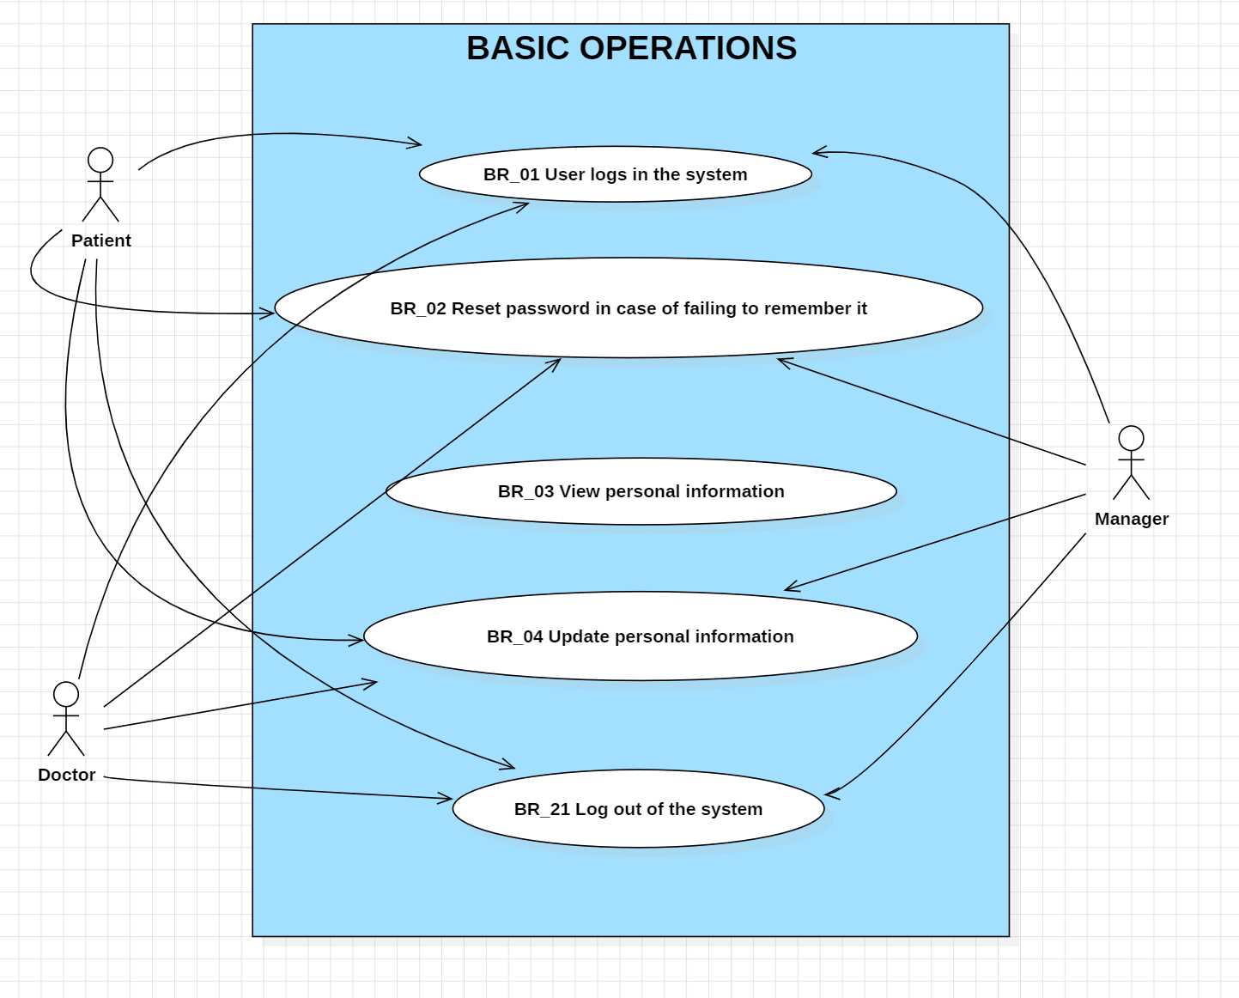

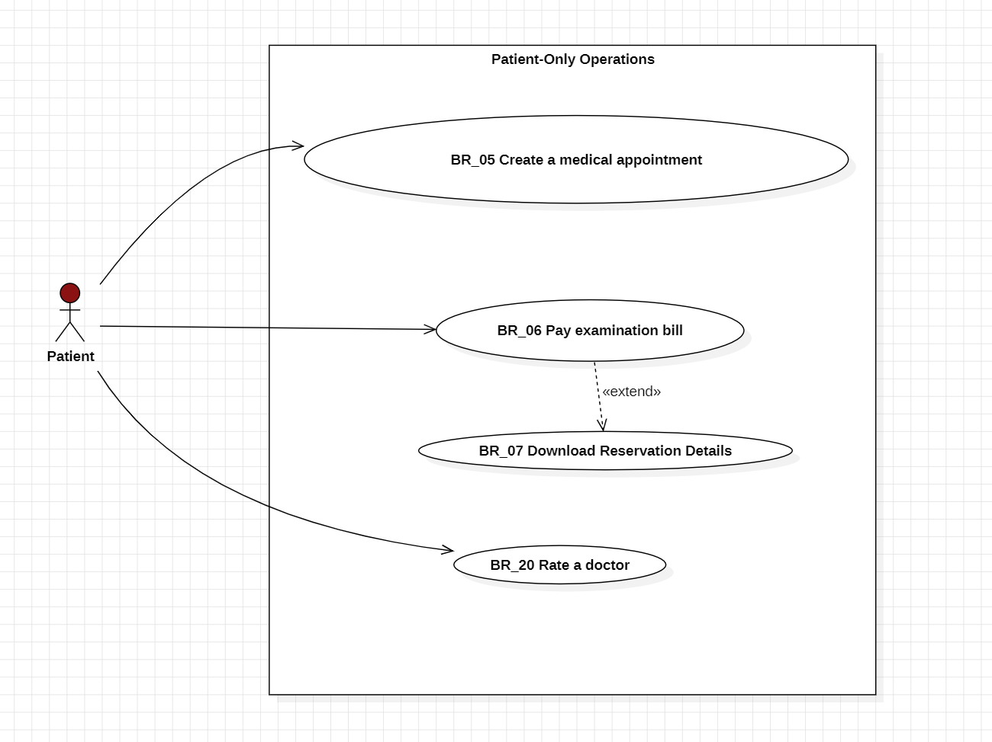

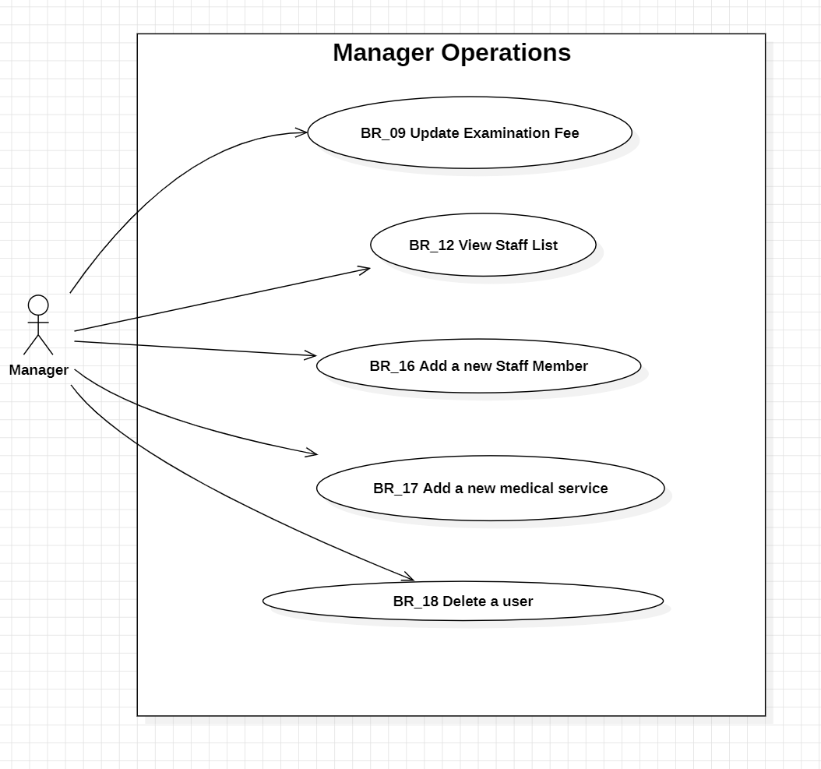

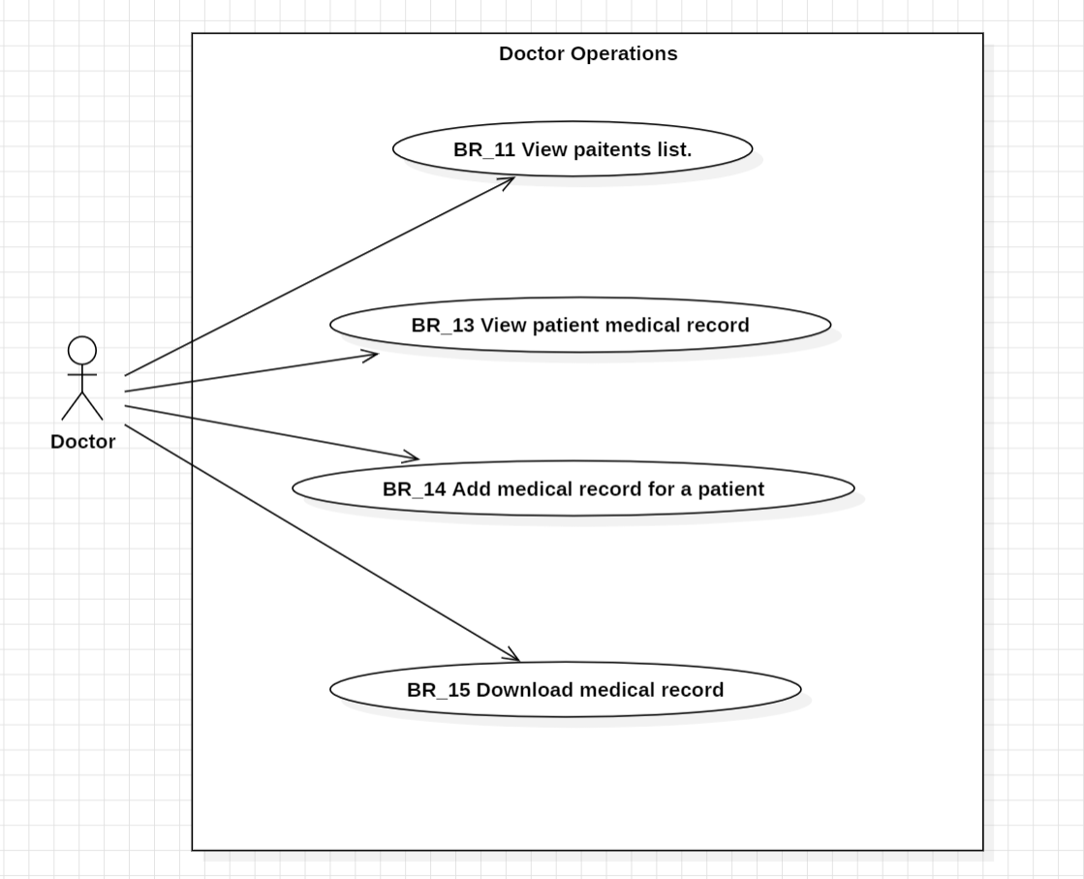

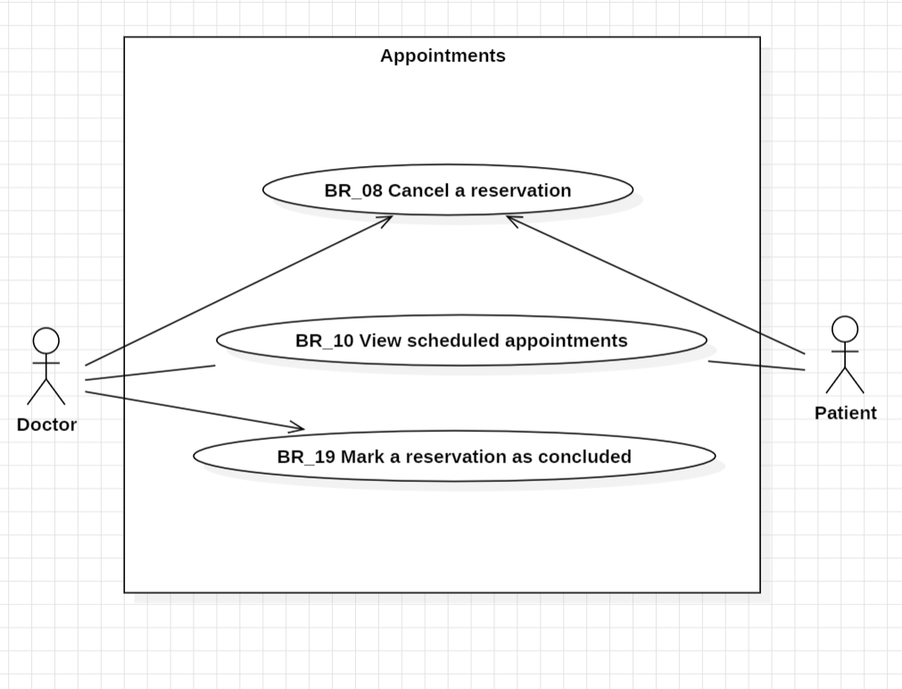

### **4.2.2 Activity Diagrams**

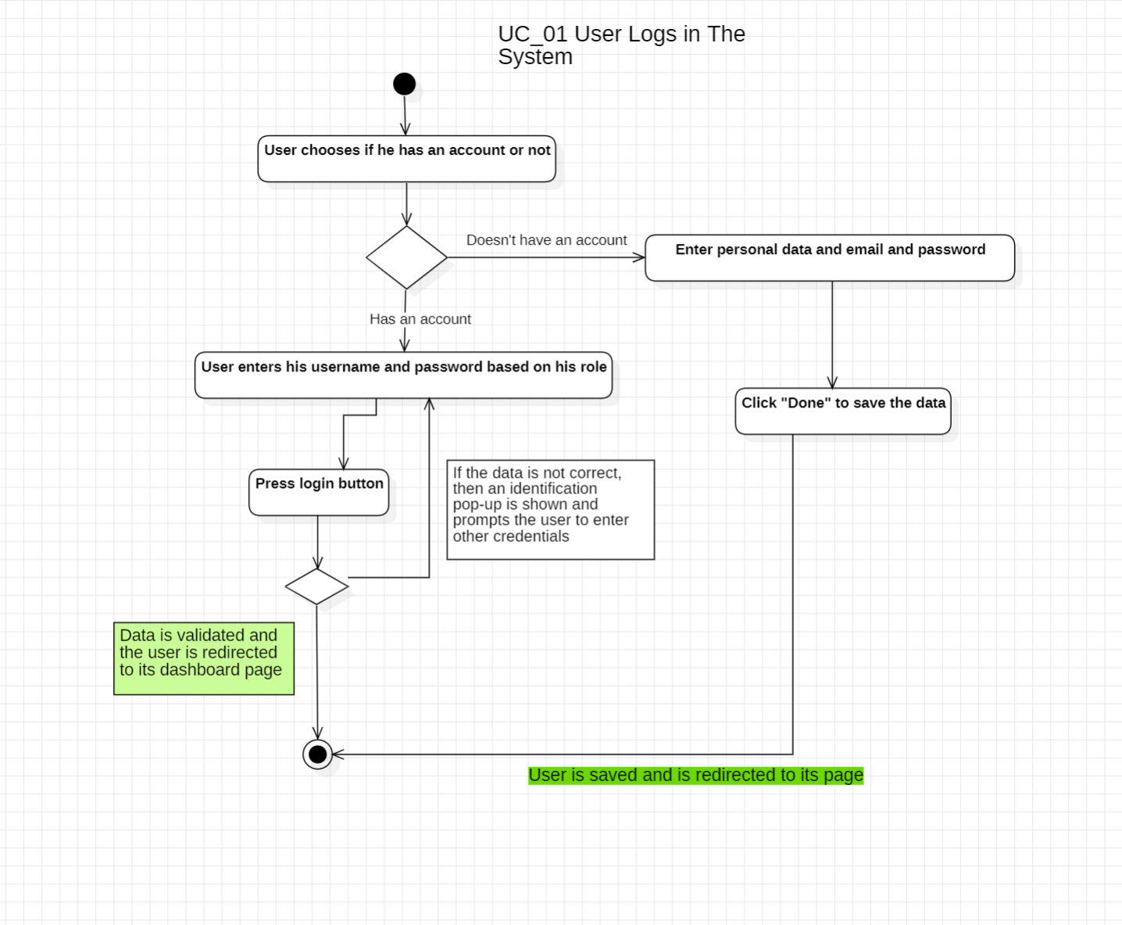

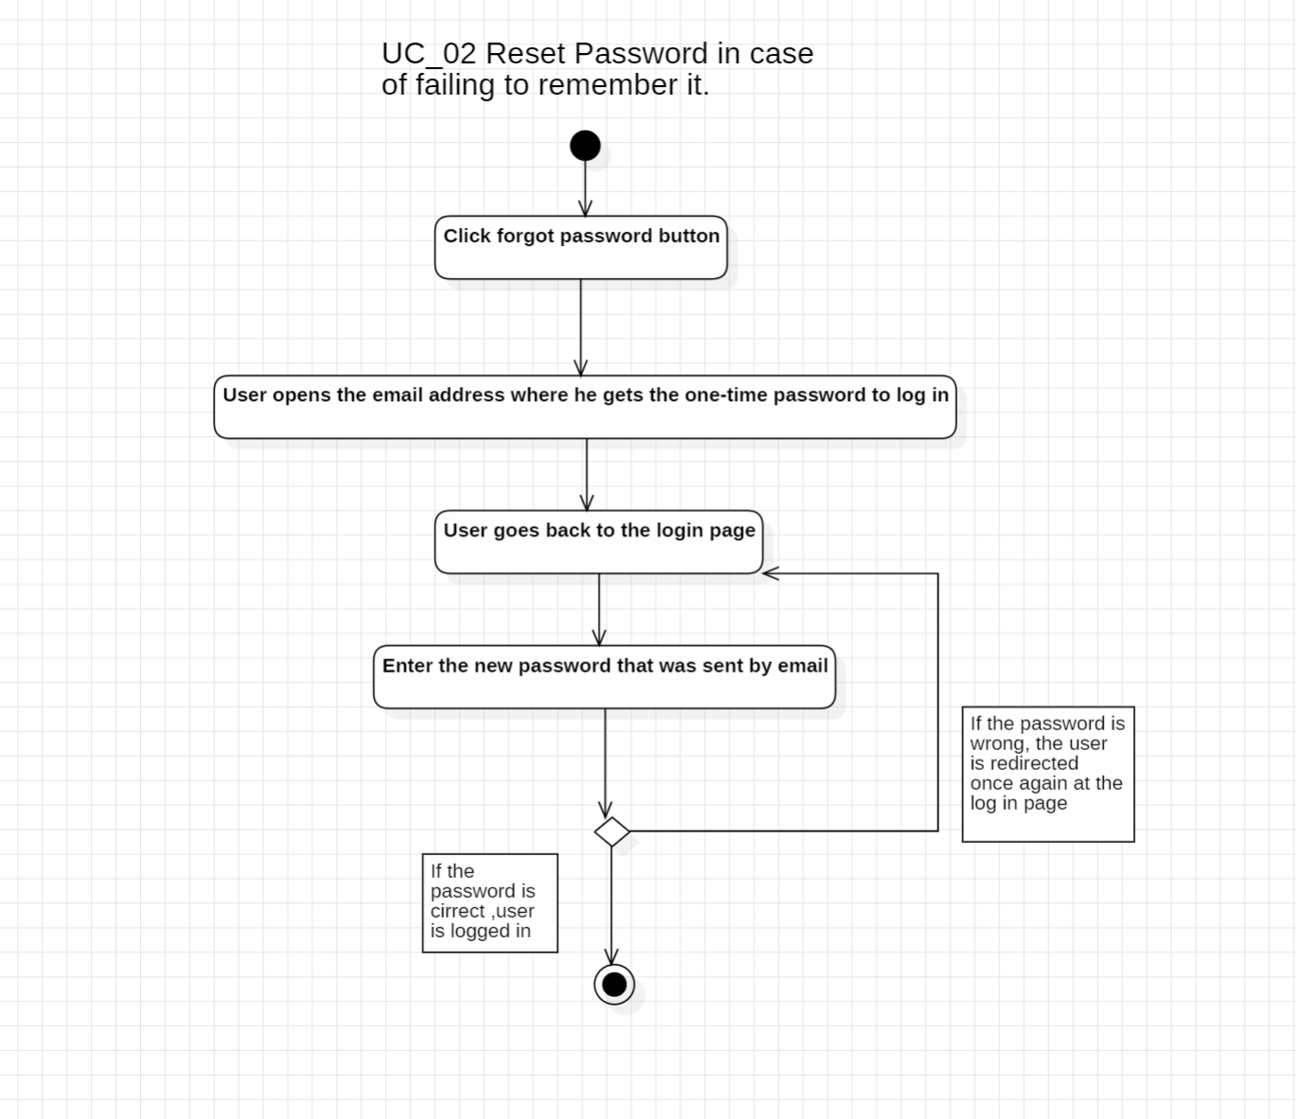

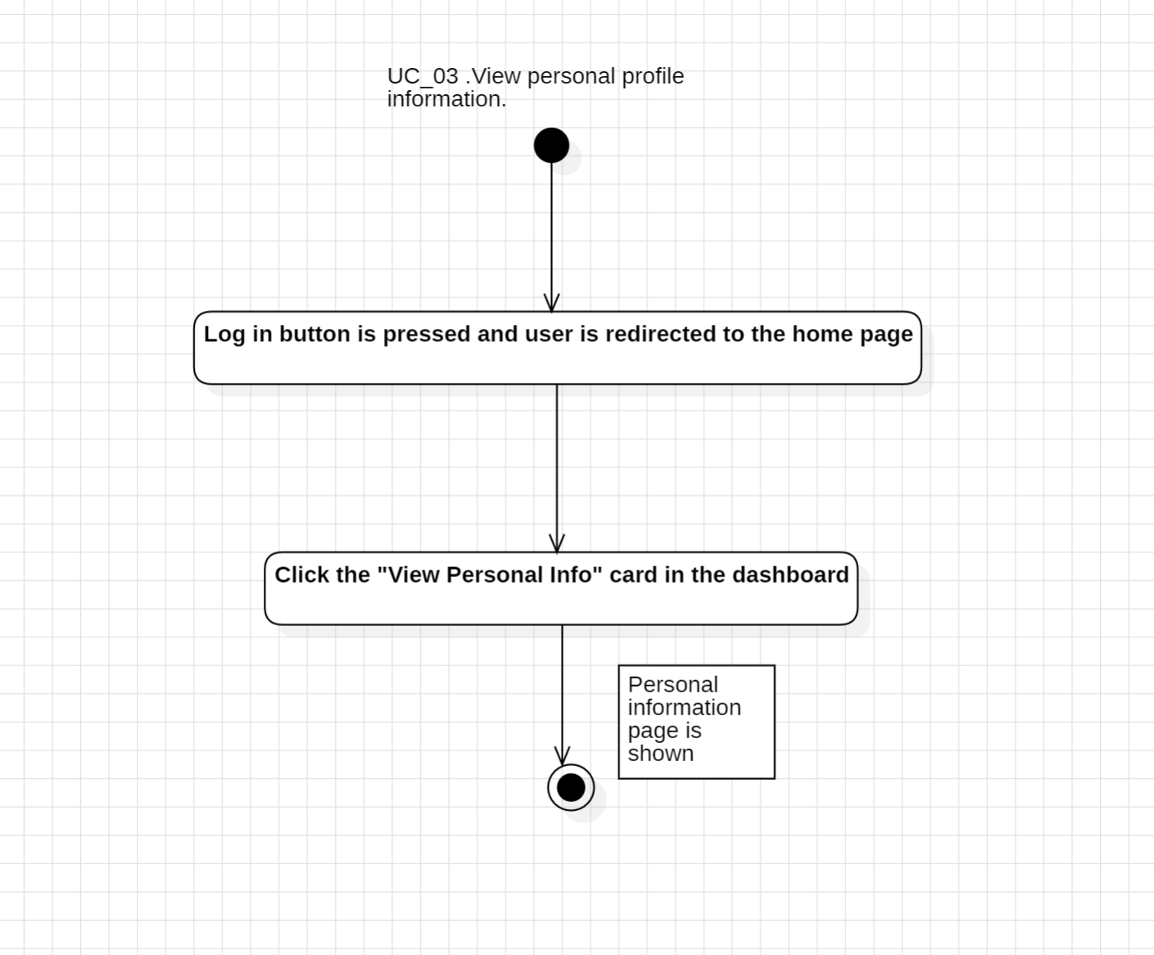

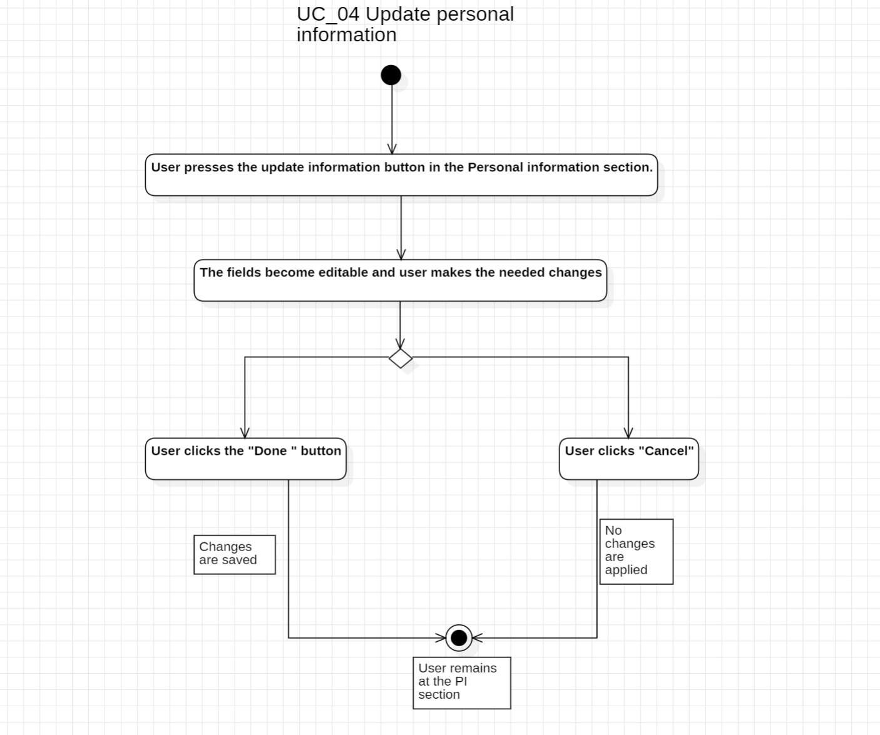

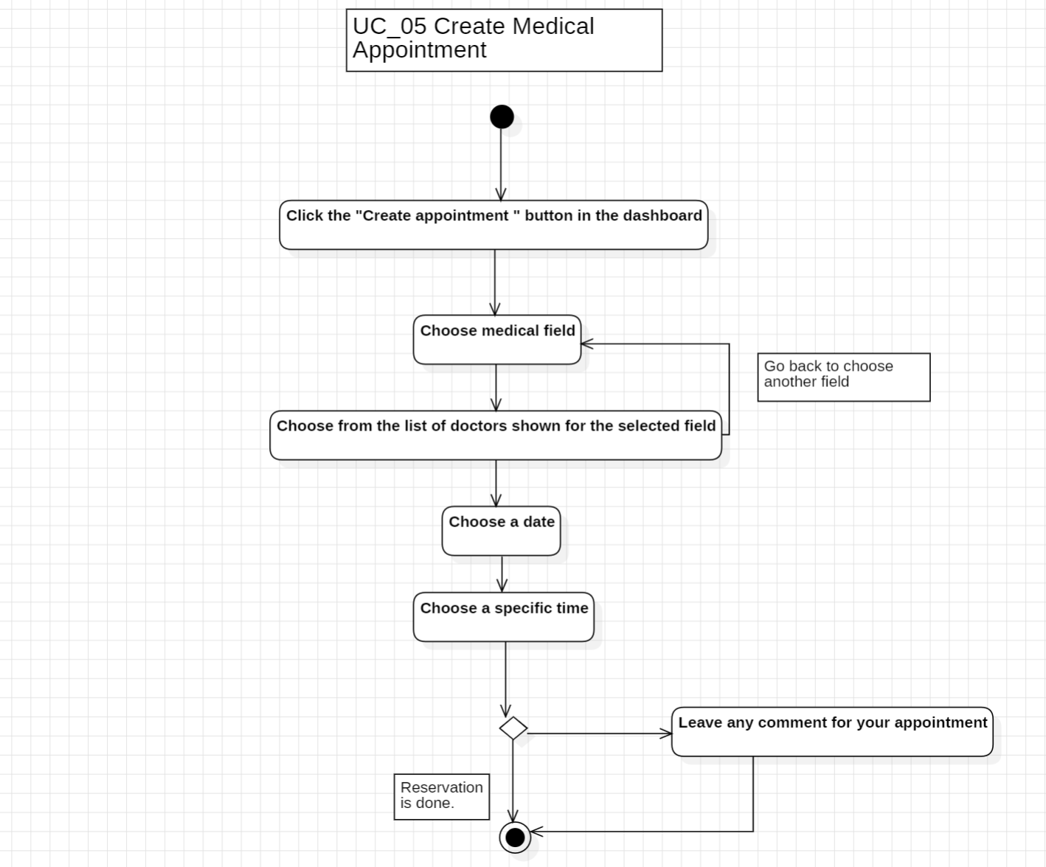

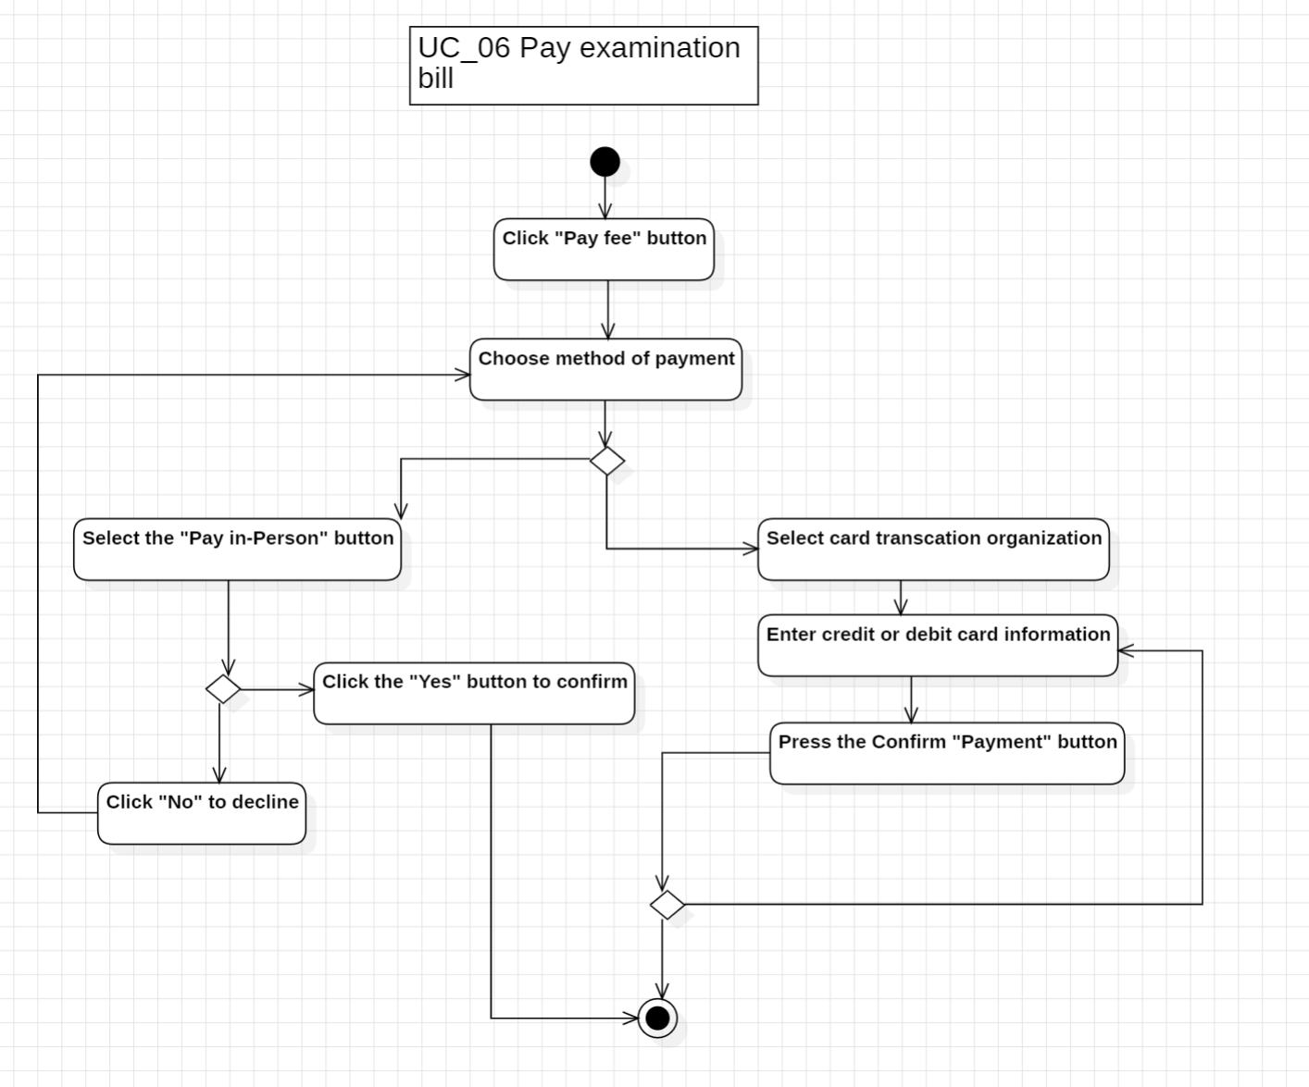

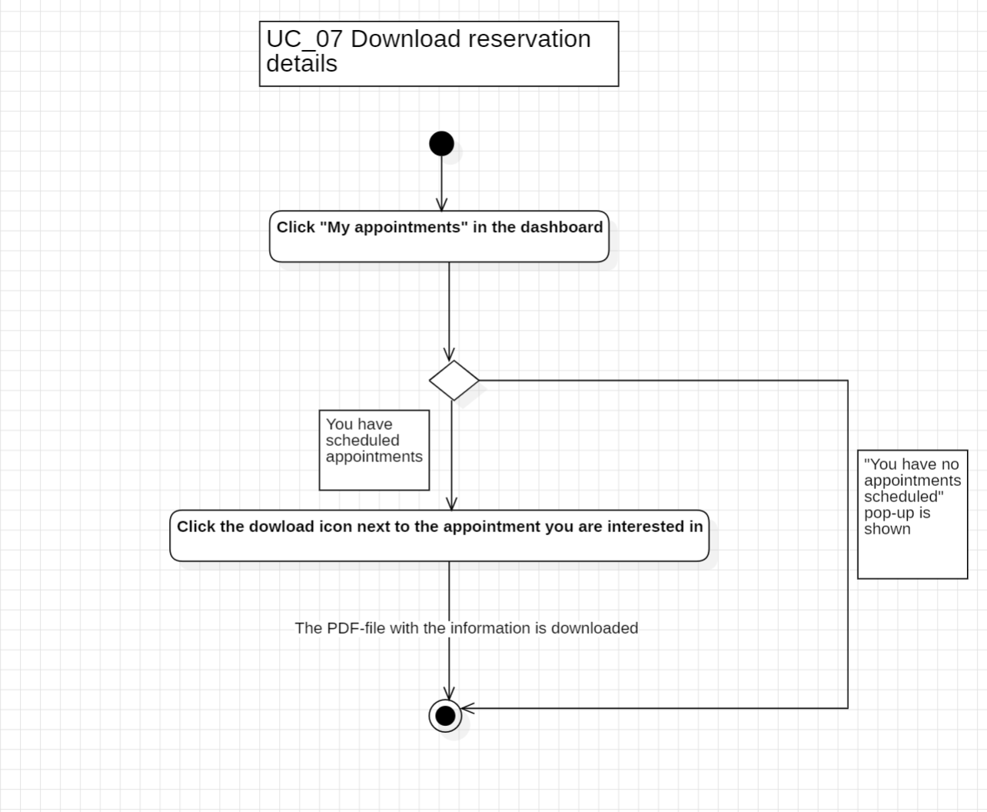

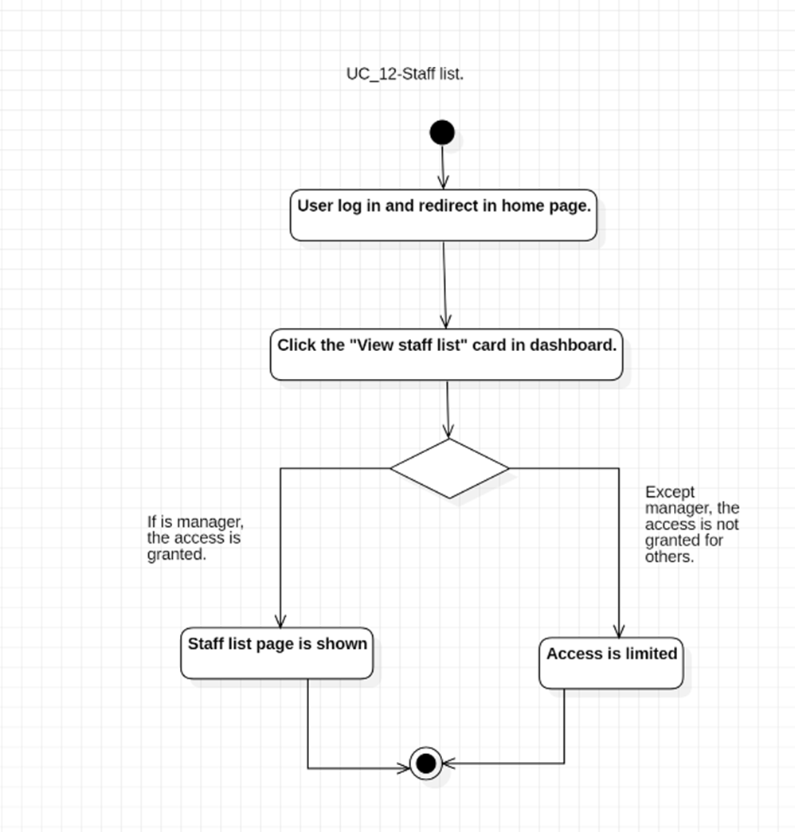

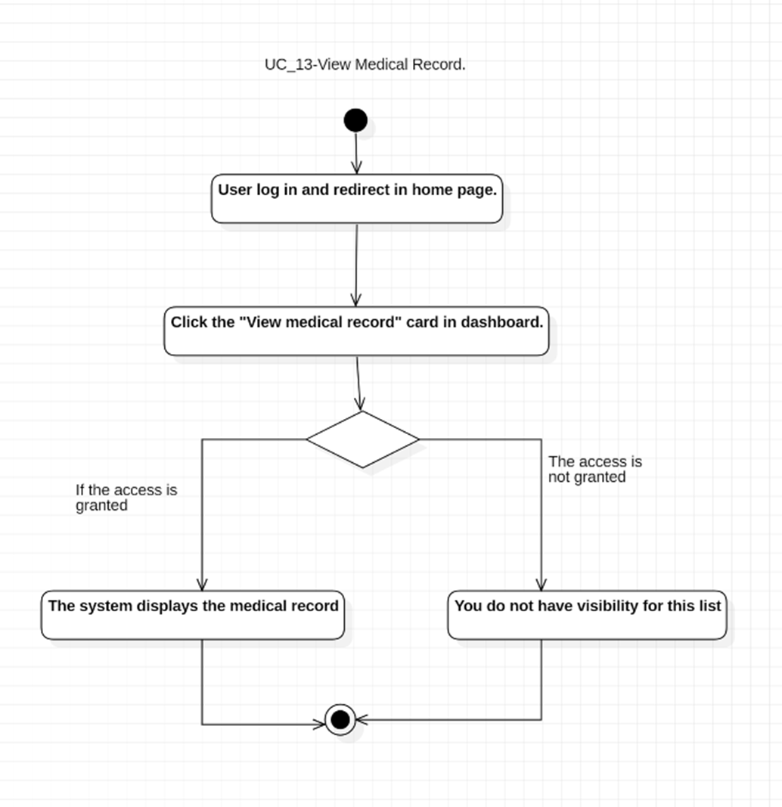

**Add new service**

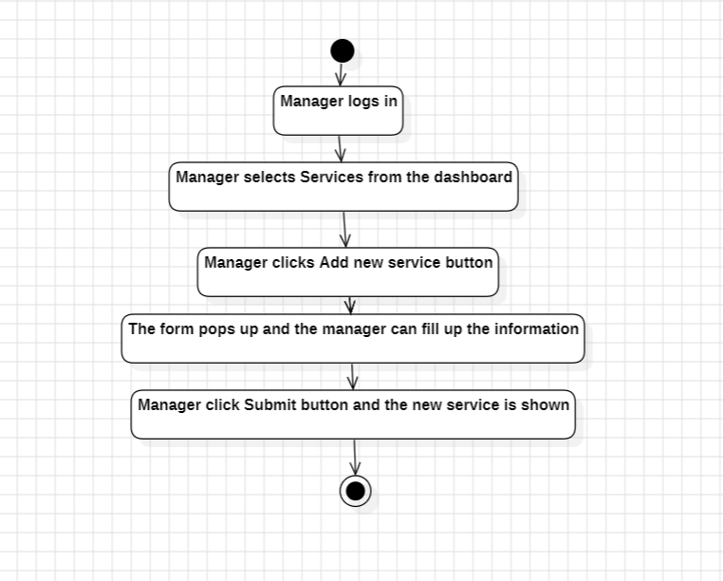

**Delete a user**

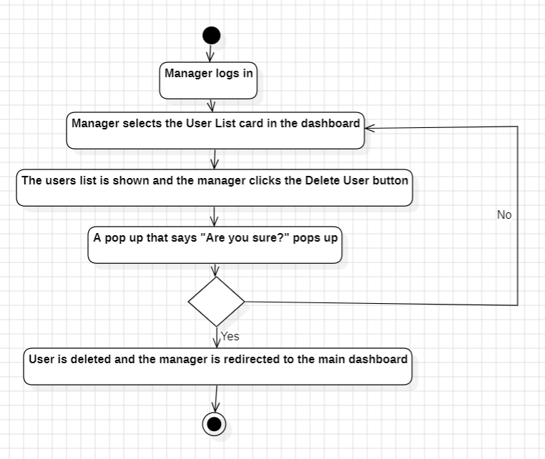

**Delete a reservation**

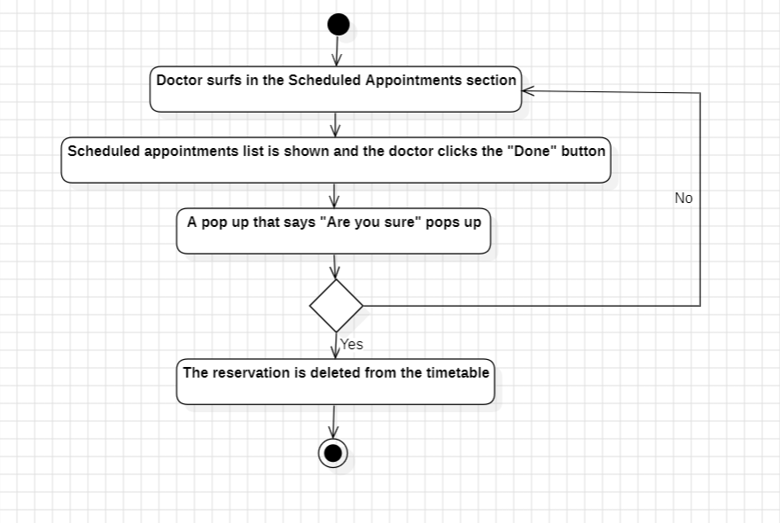

**User cancels reservation**

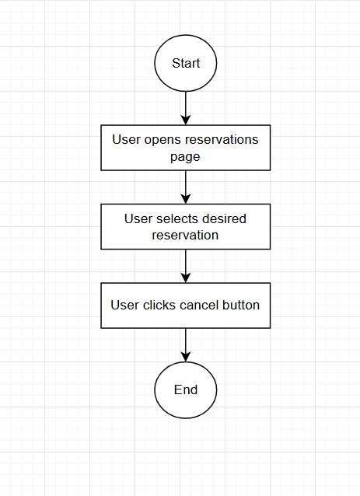

**Manager updates examination fee for doctor**

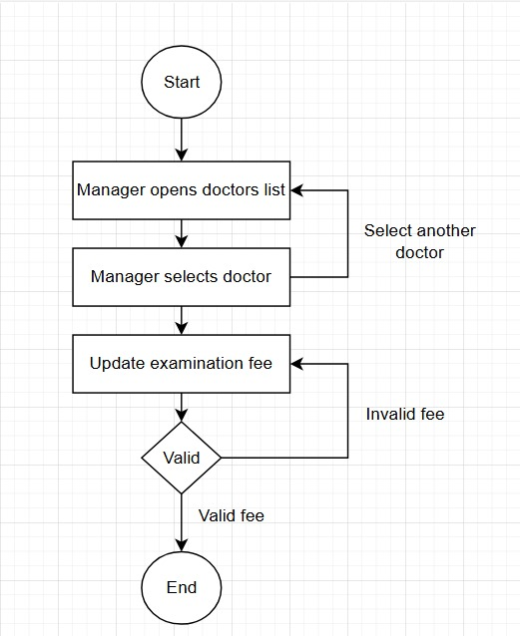

User views appointments

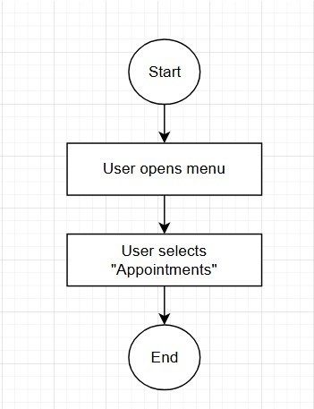

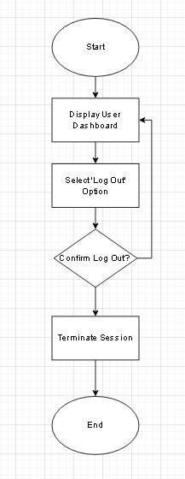**User logs out**  **User rates doctor**

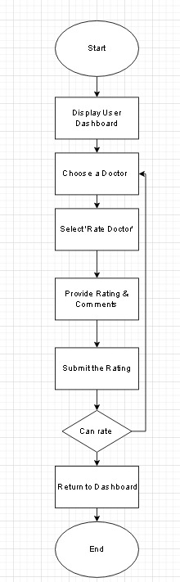

Doctor downloads a patients medical records

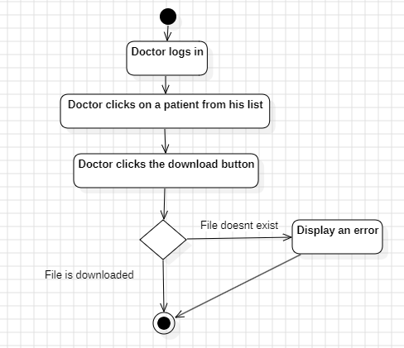

**Doctor adds medical record**

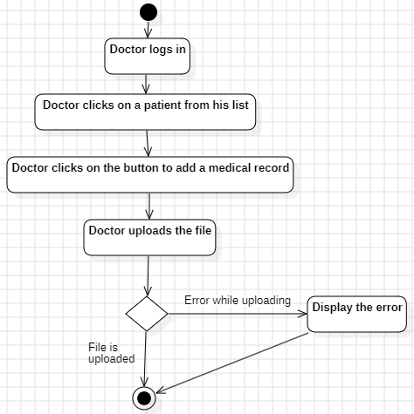

**Manager adds staff member**

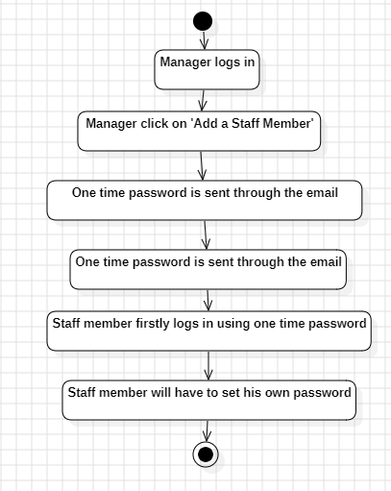

## **4.2.3 ER Diagram**

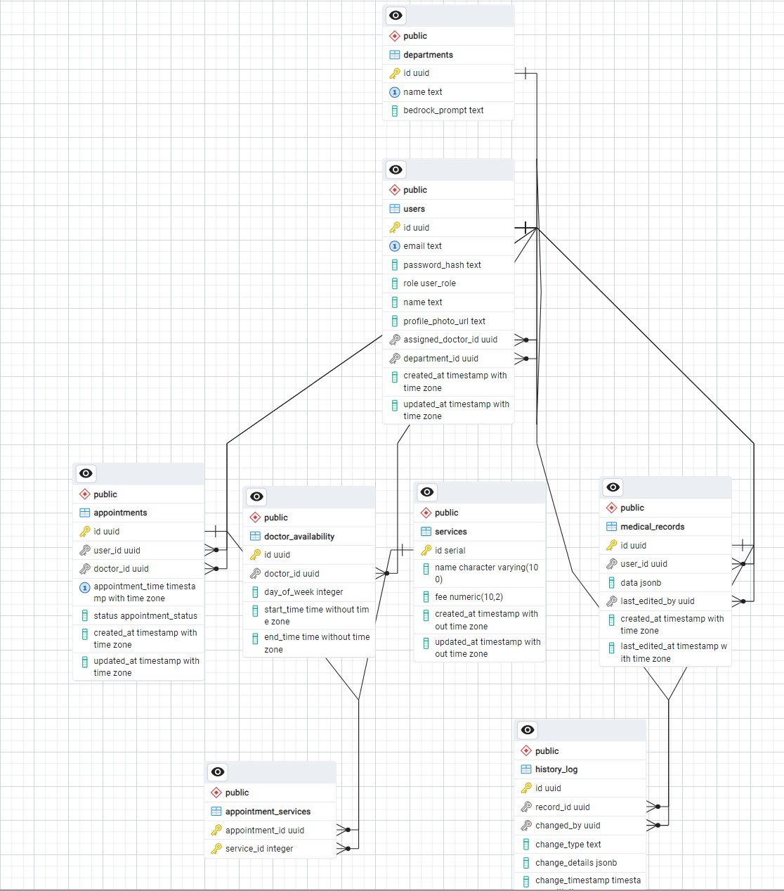

### **4.2.4 Class Diagrams**

To be put here

### **4.2.5 Sequence Diagram**

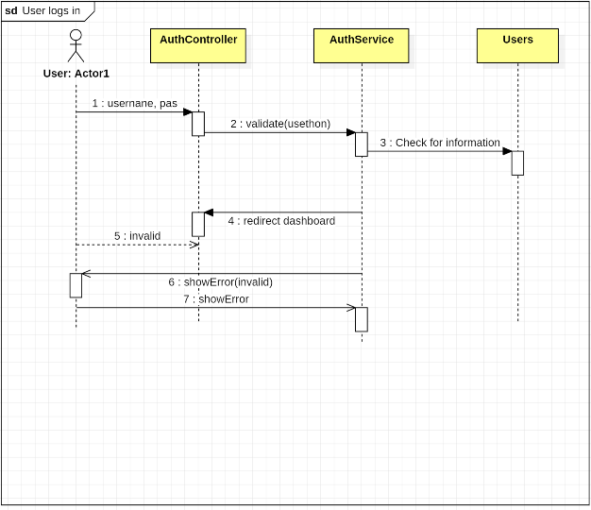

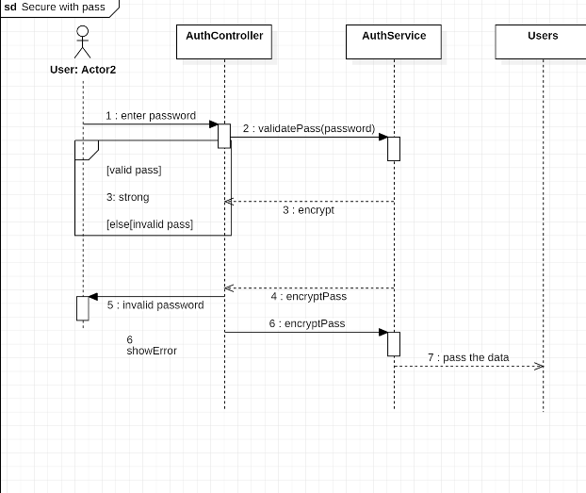

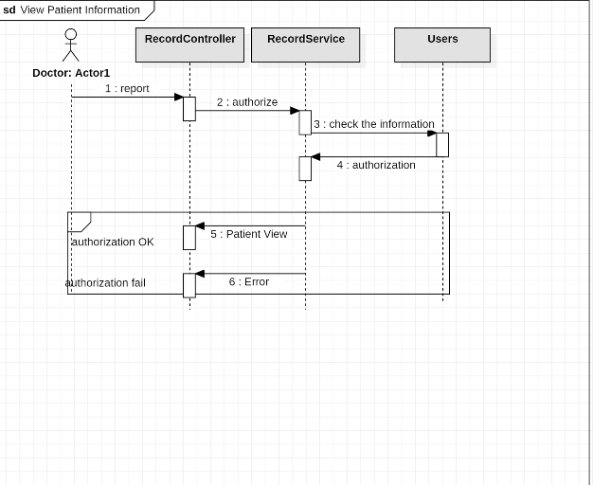

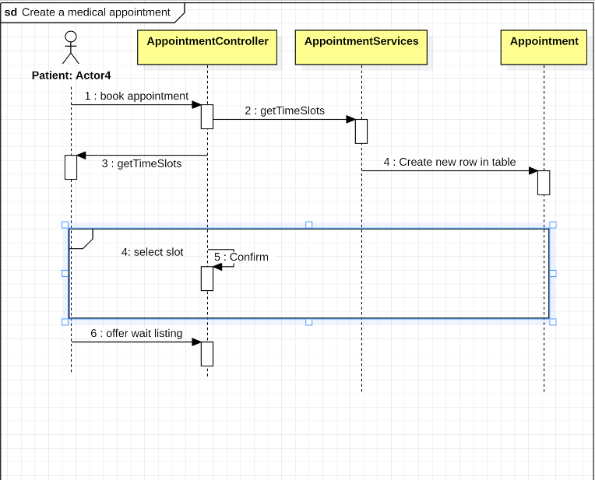

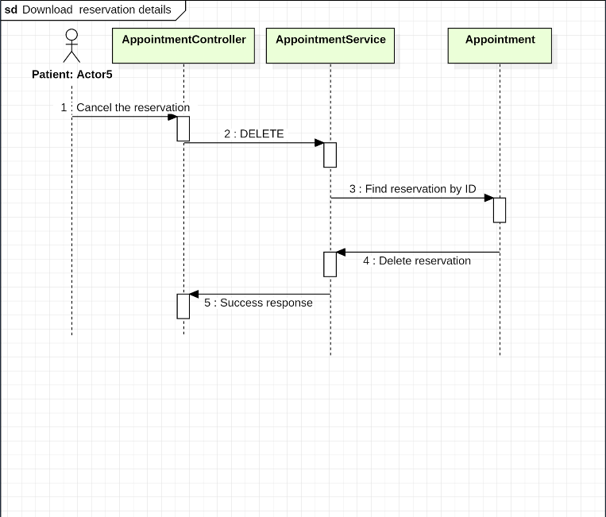

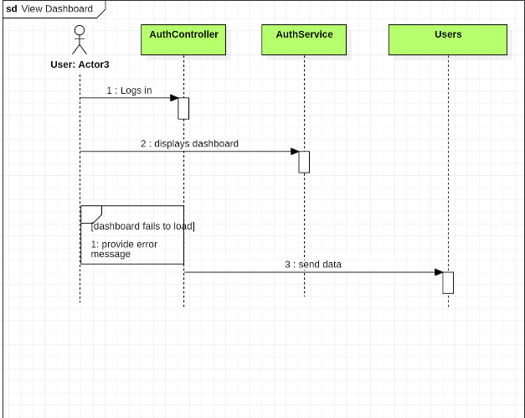

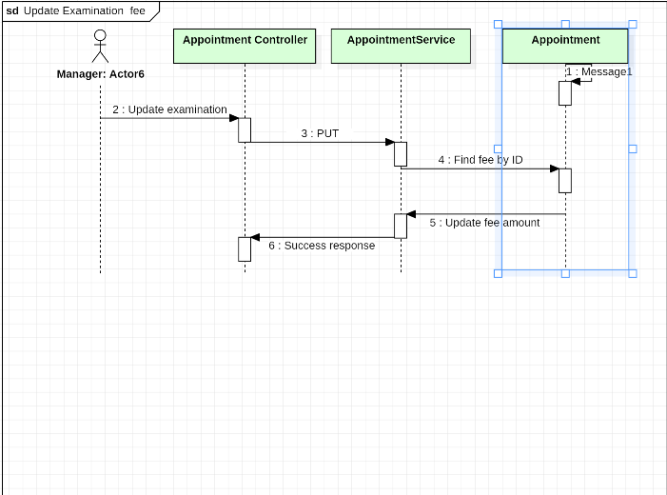

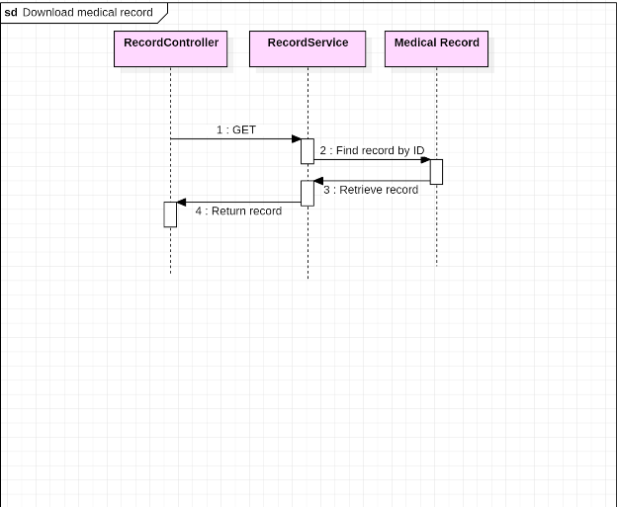

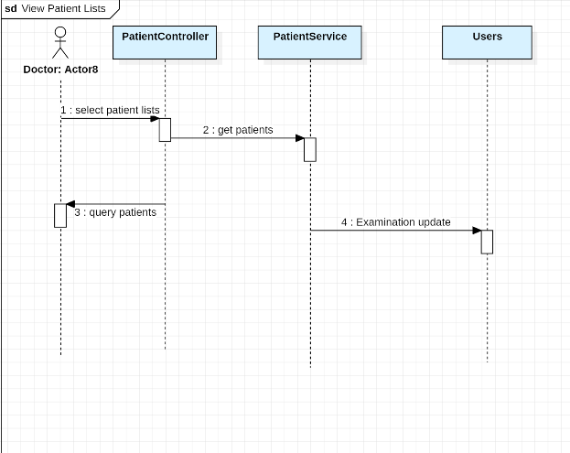

### **4.2.6 Components Diagram**

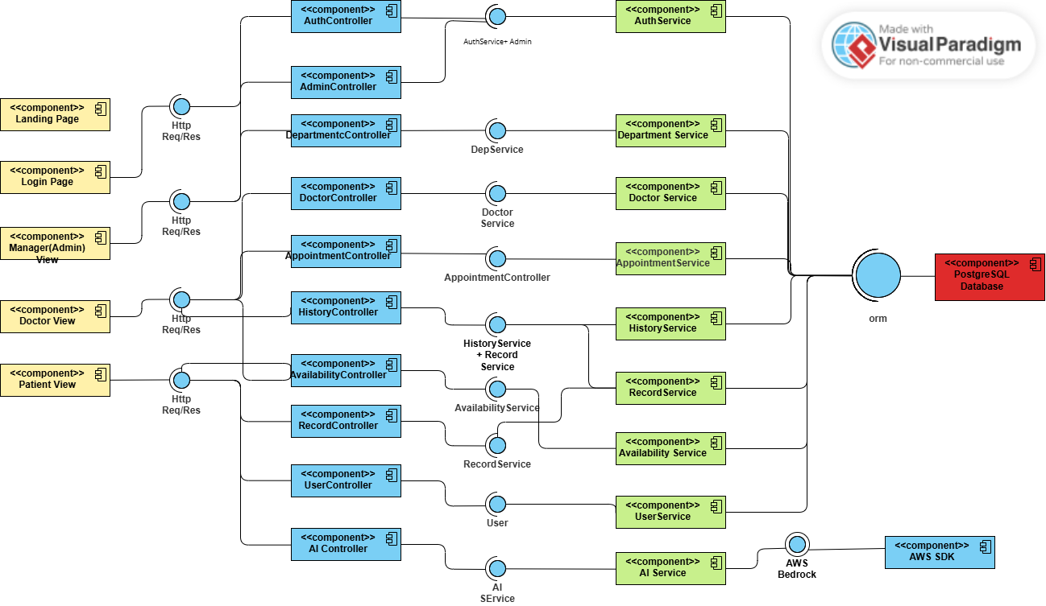

### **4.2.7 State Diagram**

